Linear Programming in Food and Agriculture

Olivia R. Grill

Department of Math, American Public University System

Math220 B001 Fall 2020: Linear Algebra

Dr. Carl F. Letsche

November 25th, 2020

Abstract

Linear programming is a form of programming that is done in order to achieve the best outcome, also known as optimization. There are many applications of linear programming, but the focus of this paper is how linear programming is used in the farming and agriculture industry. Linear programming is especially useful in farming because it allows for people to minimize wasting resources and time and maximize profit. There are many things that need to be taken into account in order to run a successful farm and business.

*Keywords*: Linear programming, constraints, maximization, minimization, optimization, feasible region

# General Description of Linear Programming

Linear programming is a technique that is applied in order to maximize or minimize an objective function. This is an important concept for people or companies that need to optimize their resources. An obvious goal of any company, farm, or business is to achieve maximum profits and minimizing the amount of time or resources needed to do that. Linear programming enables people and their businesses to achieve that.

## Different Applications of Linear Programming

Some of the different applications of linear programming include manufacturing, transportation, scheduling, and engineering. “Using linear programming requires defining variables, finding constraints and finding the objective function, or what needs to be maximized.” ( Dotson, 2018 ). A good example of linear programming is in manufacturing. Each step of the manufacturing process must work efficiently in order to produce a product or material in the fastest and most cost-efficient way possible. In order to do this, a company would use a linear expression to figure out how much raw material is required in order to avoid waste. A similar technique would be applied to figure out how much time each step in the production process took and figure out what could be improved to speed up production time. Linear programming is also used in transportation system optimization. A couple systems include airlines, buses, and train routes. All things taken into consideration include customer demand, seat prices, travel time, and passengers. Another example of linear programming is in engineering “engineers frequently aim to maximize the quantity of a particular design element (such as a material) or minimize a quantity (such as cost). To do this, they design within a set of constraints that are sometimes given by the client and other times simply the limitations of the amounts and types of available resources.” (Sullivan et al., 2018). Optimization via linear programming is vital in many different fields. For the purpose of this paper, the main subject is going to be about how linear programming is used in farming and agriculture.

### Linear Programming in Agriculture

As previously stated, linear programming is used for optimization of resources. The way that this optimization is figured out is by defining constraints for a system of inequalities. A constraint, as defined by brilliant.org, is “an inequality that defines how the values of the variables in a problem are limited. In order for linear programming techniques to work, all constraints should be linear inequalities.” (Hayes et al.). So, keeping that in mind, how could this be applied to farming and agriculture? Well, as with any consumer-based business, the economy has to be a factor in decision making. The supply-demand needs, different wants or needs based on the time of year or season, and of course labor time and costs.

Taking a look at a contribution in the International Journal of Modern Mathematical Sciences, it talks about all the different aspects of farming that need to be taken into consideration. This journal in particular talks about crops in India. “Crops planning depends on several resources like the availability of land, water, labor, and capital (Sarker and Quaddus, [12]). It also requires consideration of methods of irrigation, soil characteristics, cropping pattern, cropping intensity, topography, socio-economic conditions, climate, and many other factors.” (Sofi et al., 2015 p.161). The specific algorithm that is looked at in this study is called the simplex algorithm. It was created by Geroge B. Dantzig and it works by starting with “primal feasible bases” and then uses pivot operations “in order to preserve the feasibility of the basis and guarantee monotonicity of the objective value.” ( (Sofi et al., 2015 p.162). Danzig created the simplex model in order to deal with planning and scheduling dynamically over time, especially when there were certain aspects of this planning that were unknown. The “primal feasible basis” is an important first step in using the simplex algorithm. This is harder to obtain when the inequalities are “greater than or equal to” and “equal to”. When the inequalities contain these constraints, often times people will use a two-phase, or Big-M method which helps to convert inequalities to a form that makes them easier to deal with. On page 162 of “Decision Making in Agriculture: A linear Programming Approach”, the authors reference multiple articles that discuss how an LP approach to agricultural maximization, was far superior to the previous methods in terms of profit, time, and resources allocated. Next, let’s talk about the methodology and more of the actual mathematics behind linear programming and agriculture.

##### **Calculations**

Below is an original simple maximization problem. This is something similar to how farmers would choose a specific aspect of farming, such as production, and figure out how to maximize production based on the possible individual constraints imposed on production. This specific problem figures out maximization by using The Corner Point Principle. This principle is based off the fact that the minimum or maximum values of a set of inequalities will occur at a vertex of the feasible region.

**Question:** A farmer has decided to plant rice and cotton. Rice gives 120 bushels per acre and is sold for $4.20 a bushel. Cotton gives 85 bushels per acre and sells for $2.20 a bushel. The constraints are as follows;

1. A maximum of 110 acres of rice and cotton
2. A minimum of 15 acres of rice but no more than 70 acres
3. A minimum of 25 acres of cotton

Let X=rice and Y=cotton

* To start out, let’s find the inequalities for the constraints listed above.

1. \f[x+y\leq 110\f] ​
2. \f[15\leq x \leq70\f] ​
3. \f[y\geq 25\f] ​

* Next, graphing the inequalities will provide the “feasible region”, where all three graphs overlap. Once the feasible region is found, determine what the intersecting vertices are for the region of all three graphs. In this case, the solution will show the greatest total revenue, and the acres of each type of crop that will result in best use of acreage and profit.

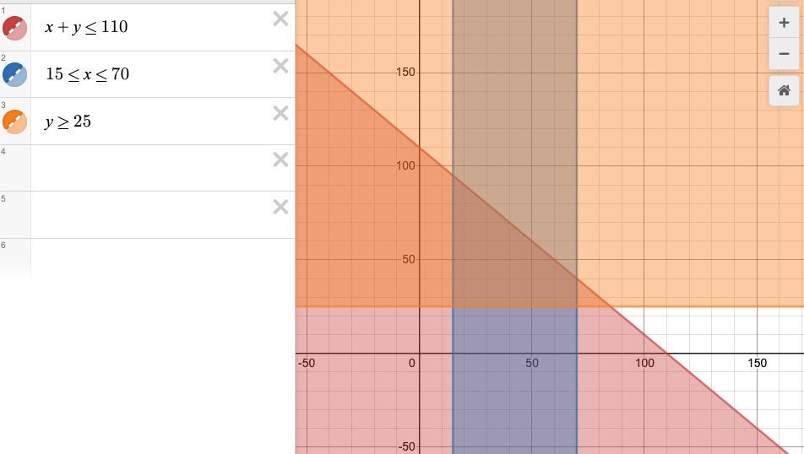

Feasible region

* In order to find total revenue, multiple the number of bushels per acre of each crop, by price per bushel, and then by its assigned variable, so in this case X belongs to rice and Y belongs to cotton.
* Once the equation for each crop is figured out, to get total revenue you add the two equations together, like below.

Total Revenue:

\f[(120)(4.20)(x)+(85)(2.20)(y)\f] 

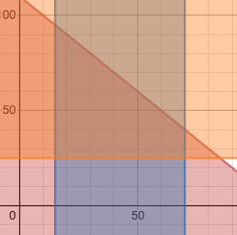

* Looking at the “feasible region” of the graph above, the vertices are (15,95), (15,25), (70,40) and (70,25).
* Using each of the vertices above, plug the X and Y values into the total revenue equation. Whichever total revenue is of largest value will result in the acreage for each crop with the greatest maximization.

|  |  |  |
| --- | --- | --- |
| **Vertices** | **Function** | **Total Revenue** |
| (15,95) | (120)(4.20)(15)+(85)(2.20)(95) | 25,325$ |
| (15,25) | (120)(4.20)(15)+(85)(2.20)(25) | 12,235$ |
| **(70,40)** | **(120)(4.20)(70)+(85)(2.20)(40)** | **42,760$** |
| (70,25) | (120)(4.20)(70)+(85)(2.20)(25) | 39,995$ |

Therefore, from the given table, it is determined, with the given constraints on the crops, that the farmer should plant 70 acres of rice and 40 acres of cotton to maximize his profits.

​

References

5.6-Linear Programming. (n.d.). Retrieved November 25, 2020, from https://people.richland.edu/james/lecture/m116/systems/linear.html

Dotson, J. D. (2018, May 21). Five Areas of Application for Linear PRogramming Techniques. Retrieved November 25, 2020, from https://sciencing.com/five-application-linear-programming-techniques-7789072.html

Hayes, A., Pakornrat, W., & Khim, J. (n.d.). Linear Programming. Retrieved November 25, 2020, from https://brilliant.org/wiki/linear-programming/

Igwe, K. C., & Onyenweaku, C. E. (2013, March 26). A Linear Programming Approach to Food Crops and Livestock Enterprises Planning in Aba Agricultural Zone of Abia State, Nigeria. Retrieved November 25, 2020, from file:///Users/oliviagrill/Downloads/1364442547-Igwe322012AJEA1609.pdf

Sofi, N. A., Ahmed, A., & Bhat, B. A. (2015, May 6). Decision Making in Agriculture: A Linear Programming Approach. Retrieved November 25, 2020, from http://www.modernscientificpress.com/Journals/ViewArticle.aspx?XBq7Uu+HD/8eRjFUGMqlRQYRj4DDs07rBArx5El0Qw50pW/3AonfkedsfsgbXoNB

Sullivan, R., Vadeen, M., Vicksman, A., Coyle, N., Anderson, R., & Zarske, M. (2018, April 11). All about Linear Programming - Lesson. Retrieved November 25, 2020, from https://www.teachengineering.org/lessons/view/cub_linear_programming_lesson01